Conference Information 會議資訊
A. Paper 論文
We invite papers on themes as follows:
- New business model for media and communication technology
- Post-truth politics and journalism
- New challenges of higher education in journalism and communication
- Development of corporate communication in Greater China area
Please kindly indicate your theme at earliest convenience for our conference scheduling. For full submission, please note the following:
- Word limit: 10,000 (in either English or Chinese, inclusive of abstract, content, data tables, appendix and bibliography, etc);
- Citation in APA format; and
- Microsoft Word document.
- Please kindly submit your ABSTRACT and PERSONAL PROFILE (see attached) no later than 21st September 2018. Please send your copies to Ms. Carmen KO, Academic Manager, by email to scom@hsmc.edu.hk.

我們誠邀以下題材之論文：
- 媒體新商業模式與傳播科技
- 後真相視角下的政治與新聞
- 新聞及傳播高等教育面對的新挑戰
- 大中華地區企業傳播的發展
請盡快告知我們閣下論文的題材，以便安排會議流程。提交論文注意事項如下：
- 字數上限：10,000字（中或英，包括摘要、內文、資料、附錄、參考文獻等）
- 請以APA模式書寫
- 請以微軟文字檔提交
- 煩請於2018年9月21日前提交論文摘要及個人簡介（參見附件），稿件請以電郵傳至教務經理高美儀女士（scom@hsmc.edu.hk）。

B. Presentation 發言埸次
- 20 minutes for one paper presentation
- 15 minutes for professional sharing (without paper submission)
- Cantonese, Putonghua and English are accepted
- If you have presentation materials, please kindly send to our Executive Assistant, Ms. Jessie CHUN (jessiechun@hsmc.edu.hk) TWO days before presentation.

- 論文發表時間每人20分鐘為限
- 專業分享（不擬提交論文的發言者） 的發言時間每人15分鐘為限
- 廣東話、普通話或英語發言皆可
- 如有簡報文檔，請於會議兩天前以電郵傳至本學院行政助理秦怡女士 （jessiechun@hsmc.edu.hk）

C. Transportation information 交通資料
- Railways: Take the Airport Express from Hong Kong International Airport to Kowloon Station (Around HKD105), then get a taxi to Hang Seng Management College (Siu Lek Yuen, Shatin) or Regal Riverside Hotel (Shatin) (Around HKD130)
- Bus: HK Airport to Regal Riverside Hotel: Bus A41; HK Airport to Hang Seng Management College: Bus A41 to Yu Chui Court, then take bus 83K to HSMC
- Taxi: From the hotel to Hang Seng Management College

- 鐵路：從香港赤臘角國際機場搭乘機鐵快線（約105港元）至九龍站，轉乘出租車（的士／計程車）至沙田小瀝源恒生管理學院或沙田麗豪酒店（約130港元）
- 巴士／公車：香港國際機場至沙田麗豪酒店:自機場搭乘A41號巴士；香港國際機場至恒生管理學院: 自機場搭乘A41號巴士至沙田愉翠苑巴士總站，轉乘83K號巴士至恒生管理學院
- 出租車／的士：住宿酒店至恒生管理學院，可搭乘出租車／的士

D. Hotel Information住宿參考資料

Regal Riverside Hotel沙田麗豪酒店（距會場約15分鐘車程）
Address/地址: 34-36 Tai Chung Kiu Road, Shatin, Hong Kong香港沙田大涌橋路34-36號
Tel/電話: (852) 2649 7878
Fax/傳真: (852) 2637 4748
Email/電郵: rrh.info@regalhotel.com

Venue Location and Transportation Map會場及交通圖
Hang Seng Management College恒生管理學院
Address地址: Hang Shin Link, Siu Lek Yuen, Satin, N. T., Hong Kong
香港新界沙田小瀝源行善里
Tel電話: (852) 3963 5000 Fax傳真: (852) 3963 5338

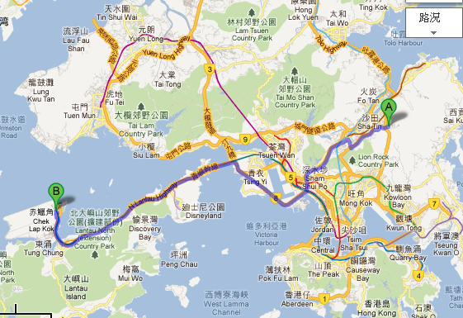
Hang Seng Management College沙田小瀝源恒生管理學院
Hong Kong
International Airport
香港國際機場

